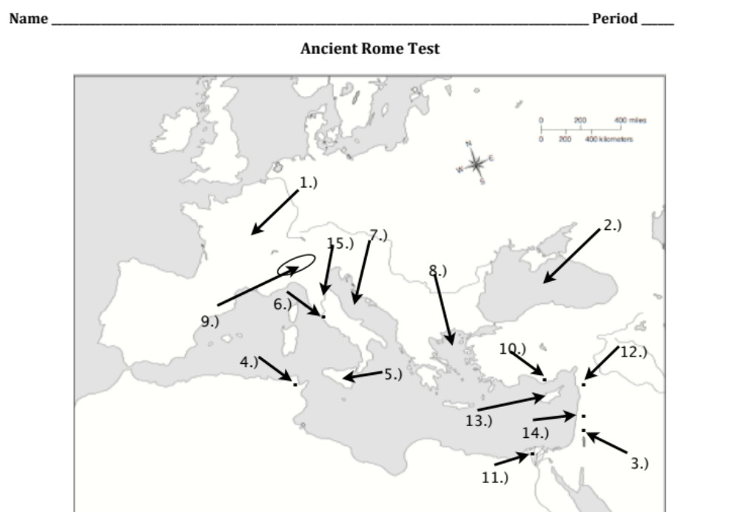

1.) What is located here?
a.) Asia Minor
b.) Gaul
c.) Africa
d.) Rome

2.) What is located here?
a.) Mediterranean Sea
b.) Adriatic Sea
c.) Aegean Sea
d.) Black Sea

3.) What is located here?
a.) Jerusalem
b.) Nazareth
c.) Bethlehem
d.) Damascus

4.) What is located here?
a.) Rome
b.) Alexandria
c.) Cyprus
d.) Carthage

5.) What is located here?
a.) Cyprus
b.) Sicily
c.) Crete
d.) Delos
6.) What is located here?
a.) Tarsus
b.) Jerusalem
c.) Rome
d.) Paris

7.) What is located here?
a.) Mediterranean Sea
b.) Adriatic Sea
c.) Aegean Sea
d.) Black Sea

8.) What is located here?
a.) Mediterranean Sea
b.) Adriatic Sea
c.) Aegean Sea
d.) Black Sea

9.) What is located here?
a.) The Drakensburg Mts
b.) The Tian Shan Mts
c.) The Tibetan Plateau
d.) The Alps

10.) What is located here?
a.) Tarsus
b.) Gaul
c.) Asia Minor
d.) Jerusalem
11.) What is located here?
a.) Rome
b.) Alexandria
c.) Cyprus
d.) Carthage

12.) What is located here?
a.) Jerusalem
b.) Nazareth
c.) Bethlehem
d.) Damascus

13.) What is located here?
a.) Cyprus
b.) Sicily
c.) Crete
d.) Delos

14.) What is located here?
a.) Jerusalem
b.) Nazareth
c.) Bethlehem
d.) Damascus

15.) What is located here?
a.) Mediterranean Sea
b.) The Tiber River
c.) The Rhine River
d.) The Danube River

16.) Which of the following is true regarding Romulus and Remus?
a.) They were rescued by a wolf from the Tiber River
b.) They were cousins who founded Rome
c.) They built Rome after overthrowing their brother, who was King
d.) They were brothers who came from Sparta

17.) Which of the following is true regarding the founding of Rome?
a.) Rome was built by brothers, Numitor and Amulius
b.) Rome was built after Remus murdered his brother Romulus
c.) Rome was built at the mouth of the Tiber River, where the brothers were saved
d.) Rome was built by both brothers, Romulus and Remus

18.) What ruling tribe conquered the Rome area before the Republic?
a.) Romulan
b.) Estruscan
c.) Remusian
d.) Latin

19.) The Roman Republic was established after the death of what monarch?
a.) Julius Caesar
b.) Romulus
c.) King Numitor
d.) Tarquinius Superbus

20.) When the Roman Republic was founded, what two groups existed?
a.) Patrician and Estruscans
b.) Plebeians and Patricians
c.) Latins and Etruscans
d.) Patricians and Romans

21.) Which of the following is true regarding Plebeians?
a.) They represented 5% of the population
b.) They are wealthy
c.) They have few rights in government
d.) They chose the governments advisors

22.) Which of the following is true regarding Plebeians?
a.) 95% of people were Plebeian
b.) They were laborers, artisans, and shopkeepers
c.) They were forced to serve in the military
d.) All of the above are true

23.) Which of the following is true regarding Patricians?
a.) 10% of people were Patricians
b.) They made up most of the military
c.) They held the best land and jobs in Rome
d.) All of the above are true

24.) How many people were in the Roman Senate?
a.) 150
b.) 300
c.) 450
d.) 500

25.) Because laws were not written down, what frequently happened to them in the Roman Republic?
a.) They were changed frequently by Patricians
b.) Plebeians changed the laws daily to favor them
c.) Nobody cared about laws
d.) Laws were often made up that were pointless

26.) In order to gain more political freedom, what did Plebeians do?
a.) They rioted in the streets and kidnapped the King
b.) They left Rome
c.) They stopped paying their taxes
d.) They attacked Rome and destroyed the city

27.) How did Plebeian representation change in the government?
a.) They no longer had to serve in the military
b.) 1 of the 2 Consuls had to be a Plebeian
c.) They were still forbidden from being in the Senate
d.) None of the above are true

28.) Why did Plebeians love Julius Caesar so much?
a.) He let them serve in the government
b.) He gave them powerful positions in the military
c.) He gave them money and valuable gifts
d.) All of the above are true

29.) What did Roman law state about generals and the Rubicon river?
a.) When returning to Rome, generals could not cross the Rubicon River
b.) Generals could only cross the Rubicon if they were alone, without their troops
c.) Only rafts could be used to cross the river as it was very dangerous
d.) Generals and their military can only cross the Rubicon under extreme emergency

30.) What significance does Caesar’s return to Rome have?
a.) He is assassinated the next day
b.) This marks the beginning of the Republic
c.) The people are angry with Caesar and vote against him being their leader
d.) This marks the beginning of the Roman Empire

31.) The first emperor to replace Julius Caesar was is adopted son. What was his name?
a.) Augustus
b.) Constantine
c.) Commodus
d.) Diocletian

32.) Hadrian’s Wall was built by Emperor Hadrian. Where was it built?
a.) Rome
b.) At the base of the Alps
c.) Carthage
d.) England

33.) This emperor is remembered for dividing the empire in half, into the Eastern and Western Roman Empires:
a.) Constantine
b.) Trajan
c.) Diocletian
d.) Nero

34.) This emperor is remembered for fighting in the gladiator games:
a.) Trajan
b.) Augustus
c.) Commodus
d.) Hadrian

35.) This honorable emperor is remembered for giving money to educate poor children and orphans:
a.) Nero
b.) Trajan
c.) Constantine
d.) Hadrian

36.) This emperor moved the empire’s capital from Rome to Byzantium, which he later renames after himself:
a.) Diocletian
b.) Nero
c.) Augustus
d.) Constantine

37.) Jesus taught his followers about God through parables. What is a parable?
a.) a simple story used to teach a moral lesson
b.) a simple story that includes animals as the main characters
c.) a complex story with several different chapters
d.) a complex story with 4 or more characters

38.) Why were Jesus’ teachings feared so much by the Romans?
a.) Jesus taught his followers to rise up and defeat the Romans
b.) Jesus teachings were of one God whereas the Romans believed in many Gods
c.) Jesus encouraged rebellion against the emperors
d.) Jesus’ teachings were feared because they were new

39.) Christians in Rome were heavily persecuted until...
a.) Emperor Constantine gave Christians the freedom to worship freely
b.) Jesus was crucified
c.) The end of Augustus’ time as emperor
d.) Paul spread the word of Jesus throughout the region

40.) Jesus taught his followers to be pacifists. What is a pacifist?
a.) One who always stands up for what they believe in
b.) Someone who refuses to fight
c.) One who tries their hardest to be kind to others
d.) Someone who wishes kindness to others

